Tsirekidze mariam
- Declare staque s and check if my constructor has constructed empty staque
- Then display staque and check if odd numbers are at the end of the staque and even numbers are at the top
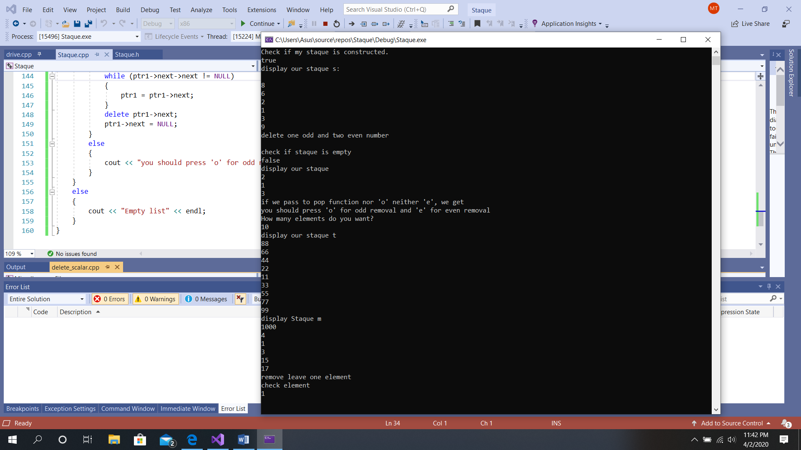
- Check if the staque is empty
- Delete one odd and two even numbers display and check if the code follows LIFO rule
5)in case you want to remove odd number you should call pop(‘o’), in case of you want remove even number you should call pop(‘e’). if we call pop(‘p’) we get:

6)Push elements by using loop.
7) create staque m and left only one member of staque.

